Figure 1 - Login

Login

Number | Description | Expected Results | Expected Results Achieved?
20.1.0.1 | Login to Trader GUI using valid Trader ID XXX. | Login Successful

User ID
The User Id is used by the system to determine the role of the user logging in. Based on this role the Trader GUI enables and disables the appropriate functionality to meet the System’s authorizations.

User Roles

Marketmaker
In addition to the Broker’s functionality:

Quote (user based)
Entry
Cancel
Update
Query
Status

Receive RFQs

Broker Dealer
Same as Customer Broker-Dealer

Customer Broker-Dealer
Order (user based)
Entry
Cancel
Cancel Replace
Update
Query
History
Status

Send Quote Request
Book Depth
Market History
Activity Log
Trade Log
Market Data

Firm Broker
Order (All firm users based)
Entry
Cancel
Cancel Replace
Update
Query
History
Status

Send Quote Request
Book Depth
Market History
Activity Log
Trade Log
Market Data

Firm Display
Order (All firm users based)
Query
Status

Book Depth
Market History
Activity Log
Trade Log
Market Data

Class Display
Market Data

Order Entry

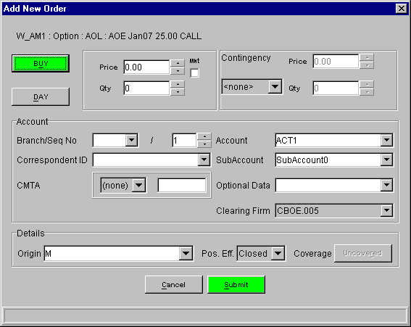
Figure 2 - Order Entry
Generic Order Entry Steps

Number | Description | Expected Result | Expected Result Achieved?
1 | Login with appropriate role  see Login and User Roles | User logged in
2 | Open a Market Display Window  see Market Display | Market Display window opened
3a | From the Market Display Window, select a product and right mouse click. | A menu will display.
3a1 | From the Order Menu, select Add New Order. | The Add Order window will display.  Order will be pre-filled to Buy at Market Ask Price and Quantity (if any). TIF will default to Day. Contingency will default to None.
3b | Or select a product and use Ctlr+Shift+N | The Add Order window will display.  Order will be pre-filled to Buy at Market Ask Price and Quantity (if any). TIF will default to Day. Contingency will default to None.
4 | Verify that the price and quantity fields are filled. If not, enter a valid price and desired quantity.  Change the order to Sell by clicking the BUY button to toggle (see Toggle Buttons Notes )  Select Open order by selecting Open from the Poss. Eff. combo box.  Enter a Branch if not using the Branch Default  Other account defaults may be set by the Miscellaneous Preferences  Verify data.
5 | To process the order, click Submit. | Button may change to “Confirm”. (See Order Confirmation for more details)  Or the Add Order window will close

Limit Orders
- Enter price by typing or using spinner on the Price field.

Market Orders
- Click the MKT checkbox next to the price filed

Contingency Orders
- Select type from the Contingency sub panel’s list of allowed Contingency types
- As applicable the Price and Qty fields in this sub panel will become enabled

Branch Notes
- A branch must be at least 1 character
- Only capital letters A-Z are allowed, no other numbers or symbols.
- Sequence number is auto generated by the GUI. To change it just enter as you would a qty
- If sequence number become out of synch on can use the option on the Miscellaneous Preferences Window to reset this value

Toggle Button Notes
The “Buy” button is a toggle button. When one presses it one will get the opposite – a “Sell” – press it again and it will be a “Buy” order. The color of the button is determined by the side.
“Buy” is green. “Sell” is yellow.

“Day” is also a toggle button. “GTC” is the other option

“Uncovered” is also a toggle button. “Covered” is the other option.

Order Confirmation
The Trader GUI has user preferences to set to determine when to require Order Confirmation.
On the dialog in Miscellaneous Preferences there is a check box to enable confirmation when qty exceeds limit and the limit value. The confirmation will be required when both of these conditions are met.

Branch Default
The Trader GUI has user preferences to set the default Branch.
On the dialog in Miscellaneous Preferences there is an Order Entry Defaults panel that contains a Branch filed. Follow the rules described in the Branch Notes for entering a valid Branch.

Miscellaneous Preferences

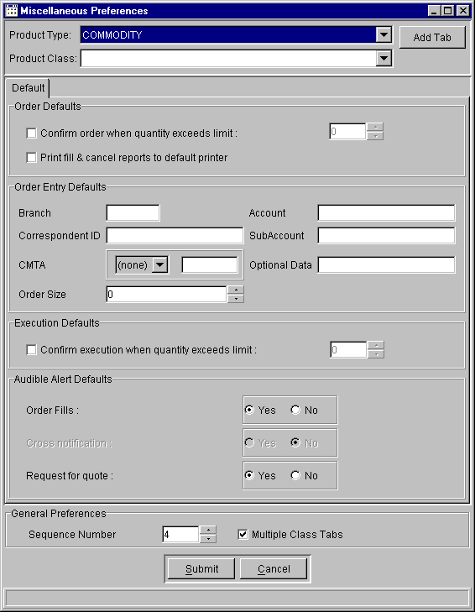
Figure 3 - Miscellaneous Preferences

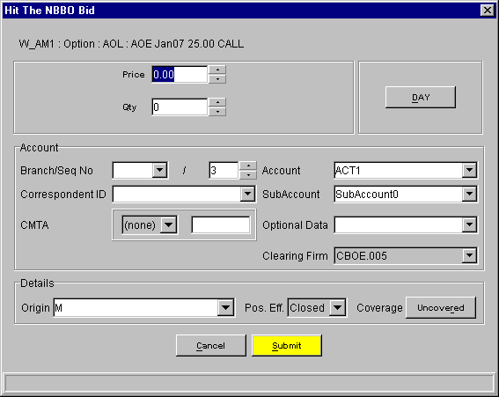
Figure 4 - Hit the Bid

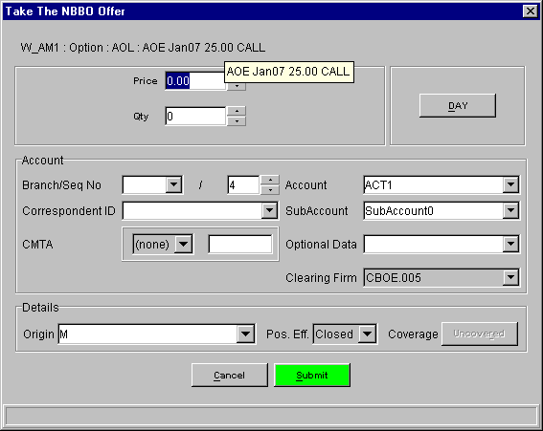
Figure 5 - Take the Offer

Hit Bid / Take Offer (CBOE and NBBO)

The only difference between this and the Order Entry is the combination of DAY and IOC. Lost are the GTC and all the other contingency types. Also these dialogs use the Execution Default value for the quantity confirmation.

DAY toggles to IOC in these cases not GTC as the Order Entry, for this reason it is moved to the other side of the panel to avoid confusion.

The only difference between the NBBO bid/offer and CBOE bid offer is the price and quantity fields being filed with the appropriate data.

The Execute menu contains 4 choices:
Hit the Bid (Cntl+Shift+B)
Take the Offer (Cntl+Shift+O)
Hit the NBBO Bid (Cntl+Shift+H)
Take the NBBO Offer (Cntl+Shift+T)

Quote Entry

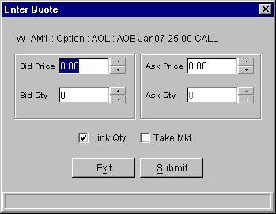
Figure 6 - Enter Quote

Number | Description | Expected Results | Expected Results Achieved?
 | From the Market Display Window, select a product.  See Market Display and Add Class | Selected series will appear highlighted.
 | From the menu bar, select Quote. | Quote menu is displayed.
 | From the quote menu, select Enter Quote. | The quote entry window will display below the ticker. Selected product and series will be pre-filled.
 | Or use Cntl+Shift+Q | The quote entry window will display below the ticker. Selected product and series will be pre-filled
 | Enter valid bid and ask prices. Enter valid bid quantity and ask quantity.  Click submit.  See Quote Defaults for user default options  See Link Quantity and Take Market for more convenience functions. | Quote entry window will close. Market Display Window will show price and quantity of quote just entered in “My Best” columns.

Quote Entry Notes
- Quote entry has 4 basic entry fields. Bid price and size and Ask price and size.
- Just as for Order Entry it has the same price and size validation.

Link Quantity
The “Link Qty” check box is a short cut to enter the same size for bid and ask.

Take Market
The “Take Mkt” check box is a short cut to getting the current market as one’s quote.

Quote Defaults
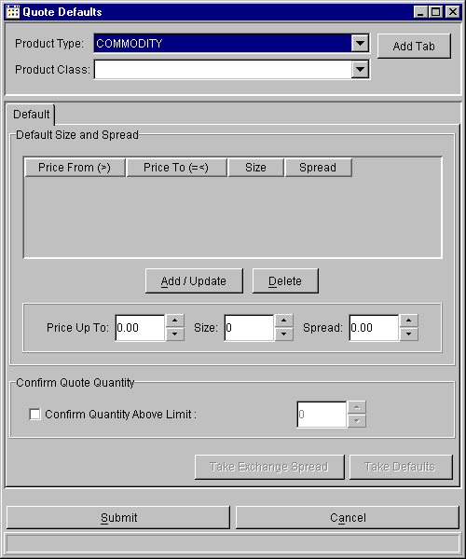
Figure 7 - Quote Defaults

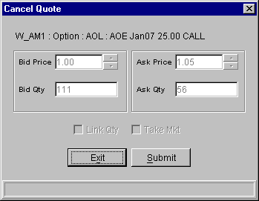
Figure 8 - Cancel Quote

Cancel Quote

The Cancel Quote dialog is straight forward. It shows the quote you have selected and your only options are to Cancel the Quote or Exit the dialog and do nothing.

Number | Description | Expected Results | Expected Results Achieved?
1 | Login with a role that allows Quote entry.  See Login and User Roles  Enter a quote  See Quote Entry | Quote entered and accepted by system, without trading or being canceled.
2 | On the Market Display Window, click on the product quoted. | Product Highlighted.
3 | From the quote menu on the menu bar, select cancel quote.  Or use Cntl+Shift+C to display the Cancel Quote | The Quote Cancel window will display on the Market Display window. It will be pre-filled with the Bid Price and Quantity and Ask Price and Quantity of the quote.
4 | Click Submit. | Quote Cancel window closes. Quote is canceled. No bid or offer will appear in the “My Best” columns for that product.

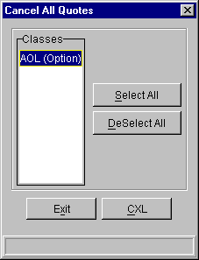
Figure 9 - Cancel All Quotes

Cancel All Quotes
The Cancel All Quotes dialog has the option to select by Class and Type, which quotes to cancel.
There are convenience buttons to select and deselect all Classes.

Number | Description | Expected Results | Expected Results Achieved?
 | Enter Quotes for at least 1 product in 4 or more Product Classes.  Verify the quotes are not traded or canceled | Quotes accepted by the system
 | From the quote menu, select Cancel All Quotes.  Or use Cntl+Shift+A | The Cancel All Quotes window will display.
 | Click Select All | All classes appear highlighted.
 | Click Cancel. | Confirmation button appears.
 | Click Confirm | Confirmation accepted
 | Select Order Status from the Orders menu. | Order Status window opens. No quotes will appear for the canceled classes.

Number | Description | Expected Results | Expected Results Achieved?
 | Enter Quotes for at least 1 product in 4 or more Product Classes.  Verify the quotes are not traded or canceled | Quotes accepted by the system
 | From the quote menu, select Cancel All Quotes.  Or use Cntl+Shift+A | The Cancel All Quotes window will display.
 | Hold down the [Ctrl] key and highlight 3 of the classes where quotes were entered. | Selected classes appear highlighted.
 | Click Cancel. | Confirmation button appears
 | Click Confirm | Confirmation accepted
 | Select Order Status from the Orders menu. | Order Status window opens. No quotes will appear for the canceled classes. Quotes will appear for classes not selected for Cancel

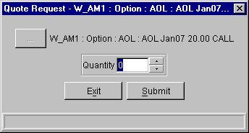
Figure 10 - Quote Request

Quote Request
This dialog allows the user to request a quote for a particular product, and optionally specifying a Quantity.

Number | Description | Expected Results | Expected Results Achieved?
 | From the Menu Bar, Select Quote | Quote menu appears.
 | From the market display window, select a current series. | Series highlighted
 | From the Quote menu, select Quote Request  Or use Ctrl+Shift+R | The Quote Request window appears for the selected series.
 | Enter a quantity. | Quantity displays in Quote Request window.
 | Click submit. | The system will send the RFQ to all Marketmakers assigned to that class. The RFQ button will flash.

Cancel Order

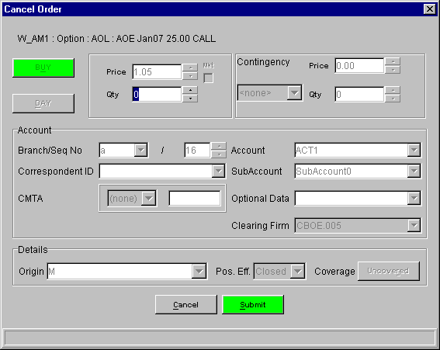

Number | Description | Expected Result | Expected Result Achieved?
 | Enter an Order so that it won’t trade or be canceled by the system.  See Order Entry for details | Order entered and available qty is the same as original qty
 | On the Order Status Window select your selection criteria in such a way as to view the order you entered.  See Order Status for details  Select the order entered during pre-test. | Order highlighted.
 | Right-click on the order. | Pulldown menu appears.
 | Select Cancel. | Cancel Order pop-up appears.
 | Click submit.  Options include changing the cancel quantity | The Cancel dialog is removed.  The Available Quantity should be decremented by the cancel quantity.  See Order Status for details

Cancel Replace Order
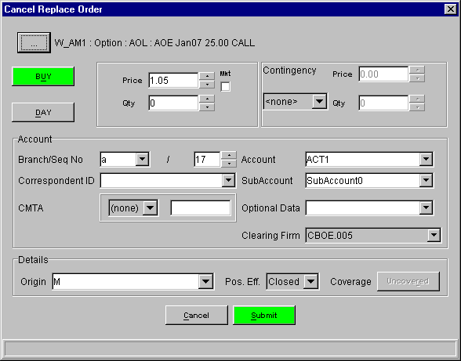

Number | Description | Expected Result | Expected Result Achieved?
 | Enter an Order so that it won’t trade or be canceled by the system.  See Order Entry for details | Order entered and available qty is the same as original qty
 | On the Order Status Window select your selection criteria in such a way as to view the order you entered.  See Order Status for details  Select the order entered during pre-test. | Order highlighted.
 | Right-click on the order. | Pulldown menu appears.
 | Select Cancel Replace. | Cancel Replace pop-up appears.
 | The existing order is displayed.  Change fields and click submit. | The Cancel Replace dialog is removed.  The Original Order should be completely canceled and a new order added  See Order Status for details

Update Order

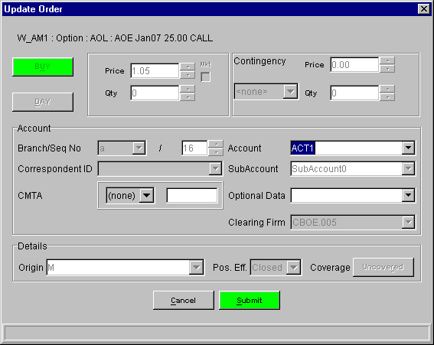

Number | Description | Expected Result | Expected Result Achieved?
1 | Enter an Order so that it won’t trade or be canceled by the system.  See Order Entry for details | Order entered and available qty is the same as original qty
2 | On the Order Status Window select your selection criteria in such a way as to view the order you entered.  See Order Status for details  Select the order entered during pre-test. | Order highlighted.
3 | Right-click on the order. | Pulldown menu appears.
4 | Select Update. | Cancel Order pop-up appears.
5 | Account  Optional Data  CMTA  The above fields are the only available fields that can be changed
6 | Click submit. | The Update dialog is removed.  Of the fields that were changed, only Account is displayed on the Order Status. Verify it is changed.  Trading priority should not be changed.  See Order Status for details
7 | Repeat steps 1-5 and verify that the  Optional Data and CMTA fields are updated.

Trades Log

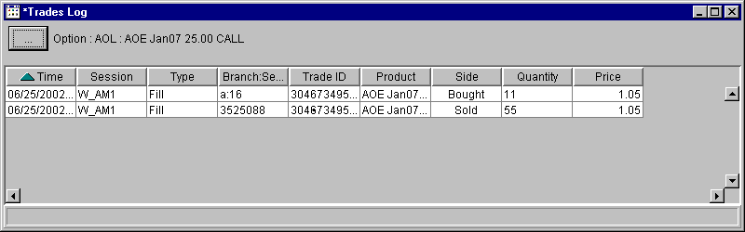

Activity Log
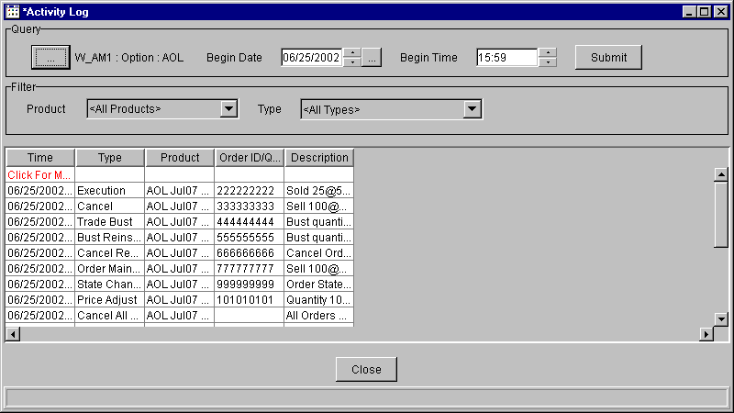

Book Depth
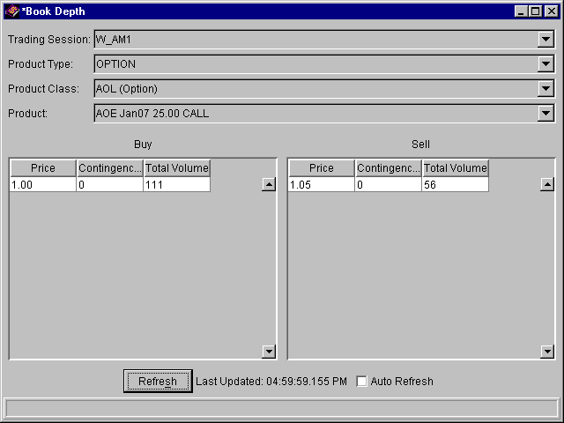

Market History
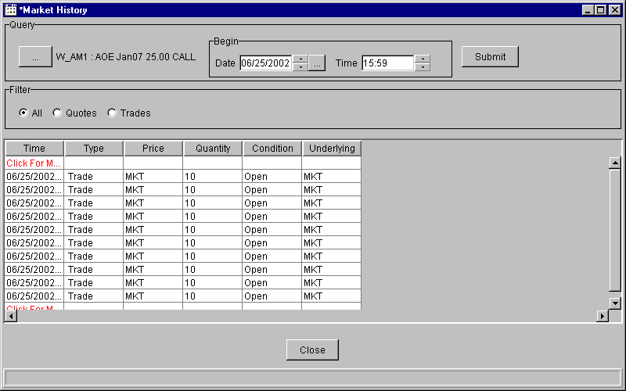

Market Display

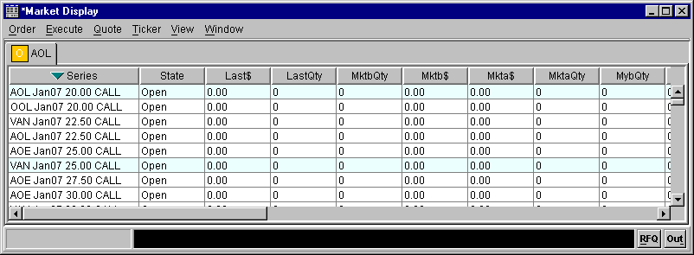
Figure 11 - Market Display

Add Class
Background Information
For each Market Display Window, the Trading Session, Product Type and Product Class will be empty the first time the window is opened. Once a value is selected, it will be remembered for the same Market Display Window. The Trading Session and Product Type can be saved as defaults for future sessions by selecting the “Set as Default” check box. The saved values are selected by default in the current and future sessions. The Trading Session and Product Type default values are saved independently of Market Display Window saved configurations.
Although the saved defaults can be changed at any time, they cannot be removed.

When selecting the Trading Session, Product Type and Product Class, the following considerations must be taken into account.
The Product Class combo box will include both Classes and Reporting Classes.
The Trading Session, Product Type and Product Class can be selected by using the mouse, or by typing the name of the session, product type or product class on their respective combo boxes.

Depending on the configuration and user preferences the tab will either be added (or selected if it exists) or the single tab will be replaced with the current Product class. See Miscellaneous Preferences.

Number | Description | Expected Results | Expected Results Achieved?
 | From the Menu Bar, Select View | View menu appears.
 | From the View menu, select Add Class.  Or use F9. | Add Class window appears.
 | Select a Trading Session, Product Type, and Product Class.
 | Press “Add Tab” | The window will close and a class tab for the selected class will appear in the Market Display Window.  Depending on the system configuration and user preferences, when “Add Tab” is pressed, existing class tabs might replaced with the selected Product Class.
Table 1 Adding a Class to the Market Display Window

Number | Description | Expected Results | Expected Results Achieved?
 | Follow the procedure to add a class to the Market Display Window (see Table 1 Adding a Class to the Market Display Window), but do not press “Add Tab” | Add Class window with Trading Session, Product Type and Product Class selected.
 | Check the “Set as Default” check box to make it selected. | “Set as Default” is selected
 | Press “Add Tab” | The Trading Session and Product Type selection is saved for future use. Note that the Product Class selection is not saved.  The window will close and a class tab for the selected class will appear in the Market Display Window.  Based on the system configuration, when a “Add Tab” is pressed, any existing class tabs might be removed.
 | Follow the procedure to add a class to the Market Display Window (see Table 1 Adding a Class to the Market Display Window), but do not press “Add Tab” | The Trading Session and Product Type combo boxes will show the saved default values.
 | Press the “Close” button. | The window will close and no class will be added to the Market Display Window.
Table 2 Setting a default Trading Session and Product Type for the Add Class window

At The Money
In the process of adding a tab (see Add Tab) to the Market Display Window, the “At the Money” series is calculated and selected in the class tab for the selected Product Class.
To determine the ATM, the following pre-conditions must be met:
- The ticker data must be available from the server.
- The current price for the underlying product for the selected Product Class has to be available from the server.
- The product type for the selected class must be Option.
Only if the conditions to calculate ATM are met (outlined above), the calculation is performed.
When the Market Display window opens, the selected series will be the closest to the “At the money” series.
If the selected class in the “Add Tab” window is a reporting class, the ATM calculation will only take into account those series that belong to the reporting class.
Note that this could mean that the selected series strike price might not be close to the underlying price, but it shall be the closest within the series for the selected reporting class.
If the selected class in the “Add Tab” window is not a reporting class, then the ATM calculation will take into account all the products for the class, regardless of the reporting class.
The selected series will be the closest to the “At the money” series.

The “At the Money” series can be explicitly selected for the selected Product Class in the Market Display Window by pressing F11, or selecting “At the Money” from the View menu, or performing a right-click on the table for the selected class on the Market Display Window and selecting “At the Money” from the View menu.
The same conditions outlined above also apply to this action.
If the ATM series cannot be calculated, the selection will not change.
If the ATM can be calculated, the series that is closest to the “At the money” series will be selected.
When requesting the ATM series explicitly all series in the class will be taken into account to determine the ATM series.
The “At the money” menu option is enabled for Option product types only.

Number | Description | Expected Results | Expected Results Achieved?
 | Add a class tab for an Option product as described in Table 1 Adding a Class to the Market Display Window. | An option class is added to the Market Display Window.  The series with the strike price closest to the underlying price will be selected.  If the ATM cannot be calculated (usually when no ticker data is available) no series is selected.
Table 3 Verifying “At the Money” series is selected upon adding a Class to the Market Display Window

Number | Description | Expected Results | Expected Results Achieved?
 | Add a class tab for an Option product and selecting a Reporting class as described in Table 1 Adding a Class to the Market Display Window | The option class is added to the Market Display Window.  The series within the reporting class products with the strike price closest to the underlying price will be selected.  If the ATM cannot be calculated (usually when no ticker data is available) no series is selected.
Table 4 Verifying “At the Money” series is selected upon adding a Class to the Market Display Window for a Reporting Class

Number | Description | Expected Results | Expected Results Achieved?
 | Add a class tab for an Option product as described in Table 1 Adding a Class to the Market Display Window | The option class is added to the Market Display Window.  The series within the reporting class products with the strike price closest to the underlying price will be selected.  If the ATM cannot be calculated (usually when no ticker data is available) no series is selected.
 | Select the View menu. | The View menu is displayed.
 | Select the At the Money option, or press F11. | The “At the Money” option is calculated and selected. The series with the strike price closest to the underlying price will be selected. If the ATM cannot be calculated, the selection will not change.
Table 5 Selecting “At the Money” series from the Market Display Window

Table Views
Background Information
Depending on the product type, the Market Display Window can display market data with one or one of two different views. Market data for Option products can be displayed with the Single Row view or the Side by Side view. Market data for all other product types can only be displayed using the Single Row view. The menu option for Side by Side view is disabled for all product types except Option products.
By default the Side by Side view shows the Call product to the left of the Series column and the Put product to the right of the Series column.
Every 5th row is shaded with a background color other than white. The background color is set to a light blue color, but the color could change depending on the color depth of the PC’s video card.
The market data table font can be changed as necessary for each class tab. The font setting is independent for each class tab, so changing the setting in one tab will not affect other tabs. Two quick methods to change the font size are provided.
To increase the font for the table, press F8, or select the View/Table/Grow menu item.
The table font shall increase a point size. The maximum point size is 72. After reaching 72 points, the font will not grow any more.
To decrease the font for the table, press F7, or select the View/Table/Shrink menu item.
The table font shall decrease a point size. The minimum point size is 8. After reaching 9 points, the font will not shrink any more.
Each tab can have its own font size.
The table font size is saved with the window configuration, so it will be restored when a saved window is opened.
To change the font family, and/or style, use the Table Preferences.

Number | Description | Expected Results | Expected Results Achieved?
 | Add a class tab for an Option product as described in Table 1 Adding a Class to the Market Display Window | The option class is added to the Market Display Window.
 | Select the View menu. | The View menu is displayed.
 | Select the Table option | The Table sub menu is displayed.
 | Select the Grow option, or press F8. | The table font size is increased one point.
 | Continue pressing F8, or selecting Grow from the View/Table menu. | The font will continue growing until it reaches 72 points. After the point size reaches 72 points, the size will not grow any more.
Table 6 Making the font larger on the Market Display Window

Number | Description | Expected Results | Expected Results Achieved?
 | Add a class tab for an Option product as described in Table 1 Adding a Class to the Market Display Window | The option class is added to the Market Display Window.
 | Select the View menu. | The View menu is displayed.
 | Select the Table option | The Table sub menu is displayed.
 | Select the Shrink option, or press F7. | The table font size is decreased one point.
 | Continue pressing F7, or selecting Shrink from the View/Table menu. | The font will continue shrinking until it reaches 9 points. After the point size reaches 9 points, the size will not shrink any more.
 | Select a second class tab. | The font on the second class tab is not changed to be the same as the first class where the font changes took place.  If a second class tab is not available, add a new class tab using the procedure described in Table 1 Adding a Class to the Market Display Window.
 | Select the first class tab. | The font on the first class tab is the same point size as it was set before selecting the second class tab.
Table 7 Making the font smaller on the Market Display Window

Number | Description | Expected Results | Expected Results Achieved?
 | Add a class tab for an Option product as described in Table 1 Adding a Class to the Market Display Window | The option class is added to the Market Display Window.
 | Select the View menu. | The View menu is displayed.
 | Select the Table option | The Table sub menu is displayed.
 | Select the Edit Preferences option. | The table preferences window is displayed.
 | Select the Display tab. | A font selector pre-selected with the current table’s font is displayed.
 | Change the font name, size and style. | The preview font changes as the name, size or style is changed.
 | When satisfied with the changes, press Ok. | The table preferences window is closed and the selected font is applied to the current table.
Table 8 Changing the default font for a class

Multiple Class Tabs
The tests specified in this section depend on the Multiple Class Tabs setting being unlocked. To verify if the Multiple Class Tabs setting is unlocked and can be changed by the user, go to the Miscellaneous Preferences window and verify that the Multiple Class Tabs setting is enabled. If it is disabled (grayed out), the feature is locked and cannot be changed by the user. If the check box is selected, then Multiple Class Tabs are allowed. If the check box is not selected, then Multiple Class Tabs are not allowed.
If the feature is locked, it can be unlocked by modifying the SBTTraderGui.properties file, located on the “etc” directory of the Trader installation as follows:
- Exit the Trader application before trying to modify the properties file. The file is overwritten when Trader exits, so any changes made while the application is running will be lost.
- Find the <>LockMultiClassTabs property in the “Defaults” section.
- Set its value to false.
- Find the <>DefaultMultiClassTabs property in the “Defaults” section.
- Set its value to true.
- Save the file.
- Login to Trader normally
- Verify that Multiple Class Tabs is not locked (see previous paragraph for details).

Number | Description | Expected Results | Expected Results Achieved?
 | Open a Market Display Window. | Market Display Window is opened.
 | Select the View menu. | The View menu is displayed. Verify that the Multiple Class Tabs is checked.
 | Add a class for any product type as described in Table 1 Adding a Class to the Market Display Window | The product class is added to the Market Display Window.
 | Add a second class for any product type as described in Table 1 Adding a Class to the Market Display Window | The product class is added to the Market Display Window.  The Market Display Window shows two class tabs.
 | Select the View menu. | The View menu is displayed.
 | Select the Multiple Class Tabs option. | This will disable Multiple Class Tabs for this Market Display Window.
 | Select the View menu. | The Multiple Class Tabs option is not checked.
 | Add a third class for any product type as described in Table 1 Adding a Class to the Market Display Window | The first two class tabs are removed and only one class tab remains with the newly selected class.
Table 9 Changing from multi class tabs to single class tabs.

Single Row View

Number | Description | Expected Results | Expected Results Achieved?
 | Add a class tab for a non Option product as described in Table 1 Adding a Class to the Market Display Window | The class is added to the Market Display Window.
 | Select the View menu. | The View menu is displayed.
 | Select the Table option | The Table sub menu is displayed.
 | Select the <> option | The Single Row option is selected and the Side by Side option is disabled.
Table 10 Verifying the Table View options for non-option product types.

Number | Description | Expected Results | Expected Results Achieved?
 | Add a class tab for an Option product as described in Table 1 Adding a Class to the Market Display Window | The class is added to the Market Display Window.  The view is set to Side by Side with the series column visible on screen.
 | Select the View menu. | The View menu is displayed.
 | Select the Table option | The Table sub menu is displayed.
 | Select the <> option | The Side by Side option is selected and the Single Row option is enabled.
 | Select the Single Row option. | The view changes to Single Row.  If a product is selected when the view type is changed, the selection will be lost.
 | Select the Side by Side view from the View/Table/<> menu. | The view will change back to Side by Side.
Table 11 Verifying the Table View options for option product types.

Side by Side View
The Side by Side view shows the product series in the middle column. Left clicking on the series column and any columns to the left of the series will select the Call product for the series. Left clicking on any column on the right side (but not including) of the series column will select the Put product for the series.
The default columns for the side by side view have been reduced to maximize the use of screen real estate. The default columns are:
Column Name | Call Product Identifier | Put Product Identifier
Product State | cState | pState
Last Sale Price | cLast$ | pLast$
Last Sale Quantity | cQty | pQty
NBBO Bid Quantity | cNbQty | pNbQty
NBBO Bid Price | cNb$ | pNb$
NBBO Bid Exchange | cNbExch | pNbExch
NBBO Ask Quantity | cNaQty | pNaQty
NBBO Ask Price | cNa$ | pNa$
NBBO Ask Exchange | cNaExch | pNExch
Market Bid Quantity | cMktbQty | pMktbQty
Market Bid Price | cMktb$ | pMktb$
Market Ask Quantity | cMktaQty | pMktaQty
Market Ask Price | cMkta$ | pMkta$
Product Series | Series* | Series*
Table 12 Side by Side View Default Columns
* = There’s only one column called Series.
Select “Show All Columns” from the View/Table menu to see all columns.
Columns that are not part of the selected columns set, will be grayed out.
Select “Show Selected Columns” from the View/Table menu to see only the selected columns.
The “Show All Columns” and “Show Selected Columns” operations apply to both the Side by Side and Single Row views.

Other columns are available in the table preferences window. The table preferences window is launched from the View/Table/Edit Preferences menu item.

Click on the “cMktbQty” or “cMktb$” column to show the “Hit the Bid” window for the Call product.
Click on the “cMktaQty” or “cMkta$” column to show the “Take the Offer” window for the Call product.
Click on the “pMktbQty” or “pMktb$” column to show the “Hit the Bid” for the Put product.
Click on the “pMktaQty” or “pMkta$” column to show the “Take the Offer” window for the Put product.
Click on the “cNbQty”, “cNb$” or “cNbExch” column to show the “Hit the NBBO Bid” window for the Call product.
Click on the “pNbQty”, “pNb$” or “pNbExch” column to show the “Hit the NBBO Bid” window for the Put product.
Click on the “cNaQty”, “cNa$” or “cNaExch” column to show the “Take the NBBO Offer” window for the Call product.
Click on the “pNaQty”, “pNa$” or “pNaExch” column to show the “Take the NBBO Offer” window for the Put product.
To “Hit the Bid” for the currently selected product (Call or Put depending on where you have clicked before) quickly, use the accelerator keys “Control-Shift-B”
To “Take the Offer” for the currently selected product (Call or Put depending on where you have clicked before) quickly, use the accelerator keys “Control-Shift-O”
To “Hit the NBBO Bid” for the currently selected product (Call or Put depending on where you have clicked before) quickly, use the accelerator keys “Control-Shift-H”
To “Take the NBBO Offer” for the currently selected product (Call or Put depending on where you have clicked before) quickly, use the accelerator keys “Control-Shift-T”
When the appropriate window shows up, some of the parameters might be entered for you already (see Miscellaneous Preferences). When satisfied with the order parameters, click Submit. Based on your preference settings, you might have to confirm the order. If prompted for confirmation, press the “Confirm” button to send the order, or “Cancel” to not send it. The order submission can be canceled by pressing the “Cancel” button at any time after the Order window comes up. This cancel operation is NOT to be confused with an Order Cancel operation. When pressing the “Cancel” button the order is NOT sent to the server, so there is no order to cancel, but you are only canceling the operation that would send the order to the server. To cancel an order that was already submitted to the server see <ORDER_STATUS>.

Add Tab
To add a tab press F9 to display the Market Display Add Class
Select the appropriate Trading Session, then Product Type and finally the Product Class.
When satisfied press the “Add Tab” button.

Depending on the configuration and user preferences the tab will either be added (or selected if it exists) or the single tab will be replaced with the current Product class. See Miscellaneous Preferences

Selecting a Product
To select a product simply left click on the row that contains the desired product.

For Side-by-Side select the appropriate column for call or put. By default the Calls are on the left the series in the middle and the Puts on the right.

Market Display Add Class
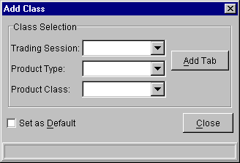
Figure 12 - Add Class

Ticker
The Market Display Window shows the ticker in the status bar.
Make sure the ticker is enabled in the preferences file located in the trader GUI installation’s etc directory. If the GUI is installed in c:\cboedirect\trader, then the file would be c:\cboedirect\trader\etc\SbtTraderGui.properties. The TickOn property of the Ticker section must be set to true.
The ticker on the status bar can be switched between ticker and recap. To change from ticker to recap or vice versa, right click on the ticker and select the appropriate option. The ticker can also be changed by selecting the appropriate option on the Ticker menu.
The ticker is also available in a stand-alone window. To start the ticker in a stand-alone window, select Ticker Display/Create New Window form the Start button on the Main Window. A new independent ticker window will appear. Both the ticker and recap are shown on this window. To change the ticker preferences, right click on the ticker window and change the preferences. Click Submit when satisfied with the changes. The changes are applied immediately to the open Ticker Window. The newly created Ticker window does not show the ticker for any class by default. To select a class, click on the product selector button (labeled “…”) and select a product class. The ticker and recap for the class will be shown on the ticker window.
If the ticker is not available from the server, a message will be shown indicating so.

Status Window
The Status Window is only accessible as a stand alone window.
To open a Status Window, go to the Main Window’s Start Menu, select Status Window and click the “Status Window” sub menu. A new Status Window will appear.
To view the details of a status report, double click on the report, or perform a single left click and select Details from the Status menu.
To print the details of a status report, open the details and select the print button, or perform single left click and select Print from the Status menu.
A Print dialog will appear with the print options can be changed. When you are satisfied with the options, select “OK” to print or “Cancel” to exit the Print dialog.

Order Status
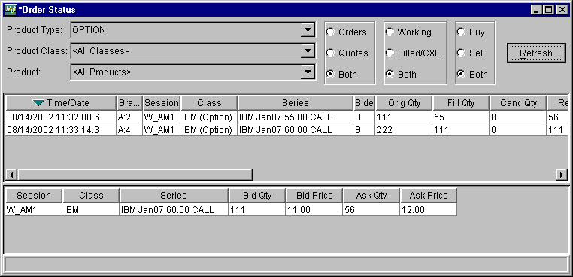
Figure 13 - Order Status

Order Operations

Cancel Order

Cancel Replace Order

Update Order

Order History

